Assignment 2, KNN Algorithm

Alla Topp

* 1. **Get to know your data, start out by data exploration (show the results with the corresponding discussion/interpretation).**

Heart Disease Data Set

Objective: to predict heart disease in patients.

Only 14 attributes used (columns):

1. (age) age in years

2. (sex) (1 = male; 0 = female)

3. (cp) chest pain type

4. (trestbps) resting blood pressure (in mm Hg on admission to the hospital)

5. (chol) serum cholestoral in mg/dl

6. (fbs) (fasting blood sugar > 120 mg/dl) (1 = true; 0 = false)

7. (restecg) resting electrocardiographic results

8. (thalach) maximum heart rate achieved

9. (exang) exercise induced angina (1 = yes; 0 = no)

10. (oldpeak) = ST depression induced by exercise relative to rest

11. (slope) the slope of the peak exercise ST segment

12. (ca) number of major vessels (0-3) colored by flourosopy

13. (thal) 3 = normal; 6 = fixed defect; 7 = reversable defect

14. (num) (the predicted attribute) diagnosis of heart disease (angiographic disease status)

We start our analysis with exploration of the data. We can see the summary of the table we have below:

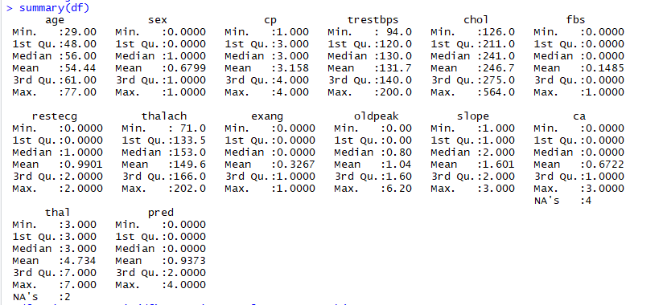

Some of the column can show some numbers visually. I built histogram plots of four columns where we could see the age of patients, serum cholesteral, resting blood pressure, maximum heart rate achieved. Below we can see that age of patients mostly between 55 and 60, also we can see that resting blood pressure is 120-130 in most cases and maximum heart rate achieved at 150-160.

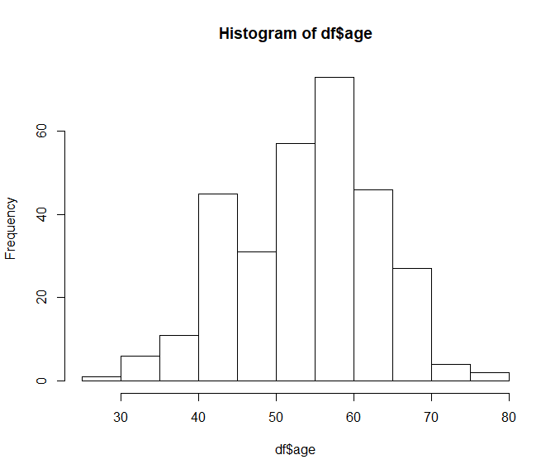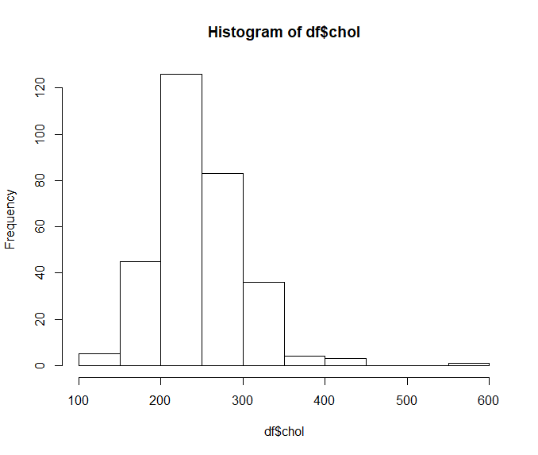

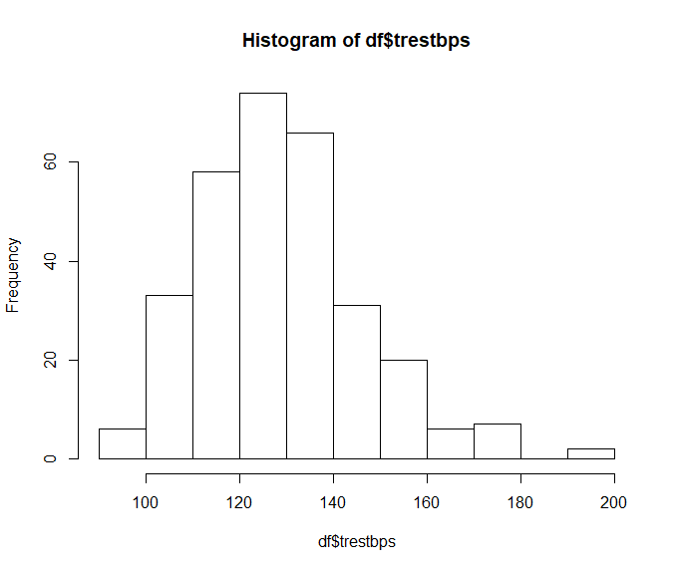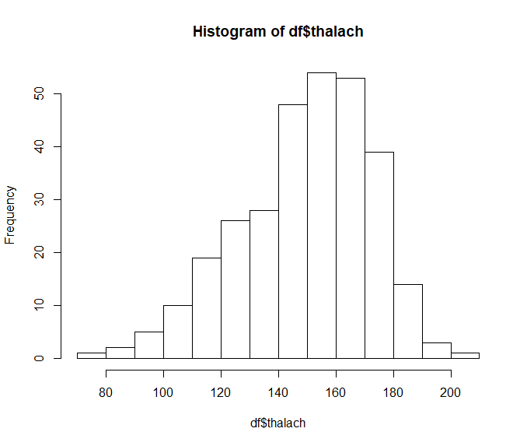

* 1. **Divide the data into a training set and a test set randomly with ratio 70:30. Make the prediction based on 1-nearest neighbor. What is the error rate of this approach?  Report the confusion matrix and accuracy. Interpret the results.**

At this part we will identify which rows and columns have missing values, we can see it after running function view() and we can see that column 12 and column 14 together have 6 missing values. After that we remove the rows with missing values with function df.omit().

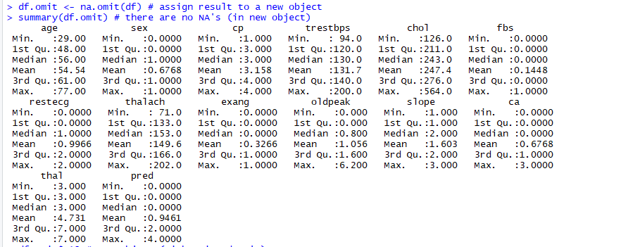

To make our data more precise without overfitting we should normalize this dataset and to rescale the features to a standard range of values. Now data range is between 0 and 1.

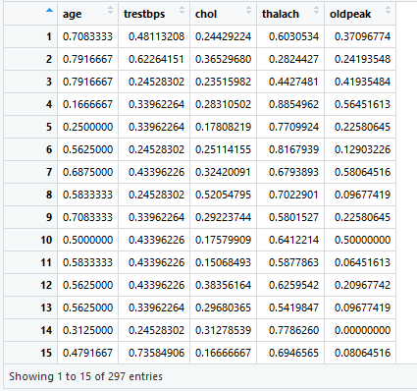

As seen above, cholestoral which used to have a min of 126 and a max of 564, now has values ranging between 0 and 1. The same with age, trestbps, thalach and oldpeak.

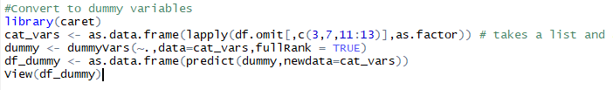

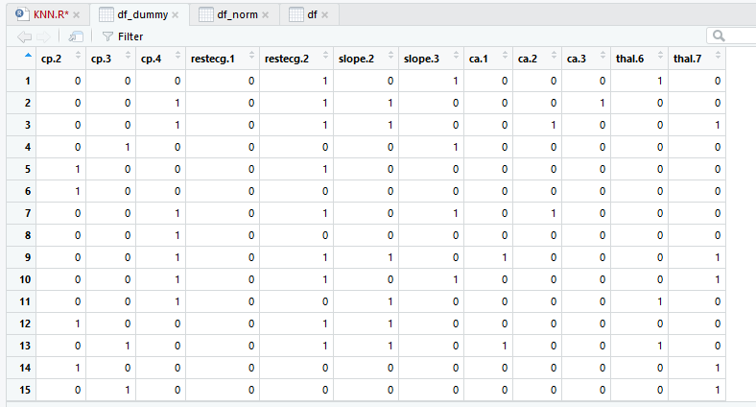

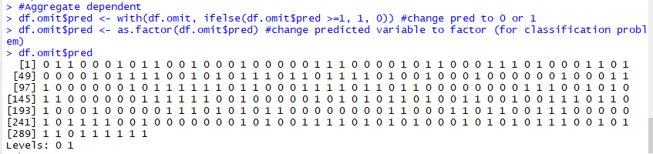

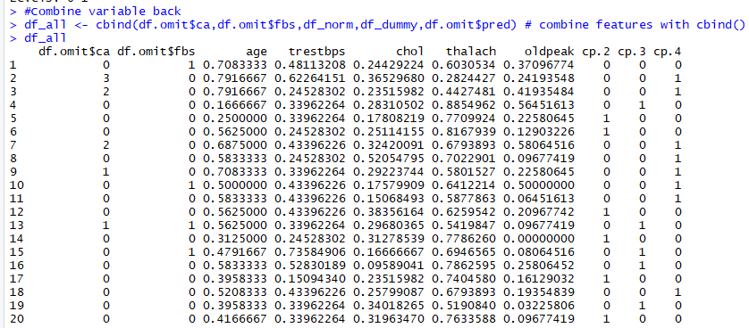

Before we run KNN algorithm we should split data into training and test sets to the 70/30.

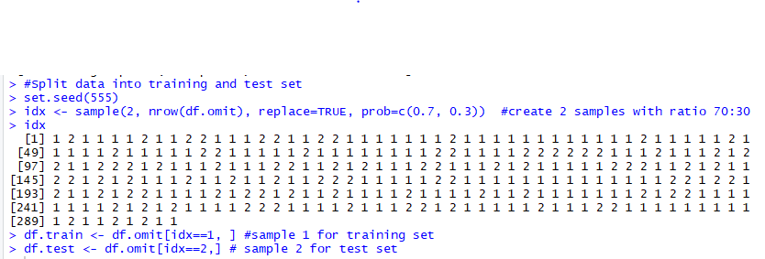

Now we have them and we can run KNN with different values of K, so we can identify the most optimal value and accurate result.

* 1. **Use different values for K, what is the optimal value of K from your experiments?**

First, we try to run the algorithm **with K=1**, the we evaluate the model by building Cross Table with true positive and negative results and false positive and negative results.

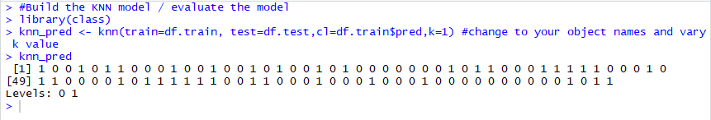

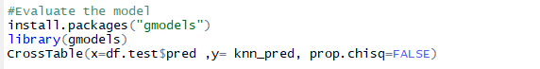

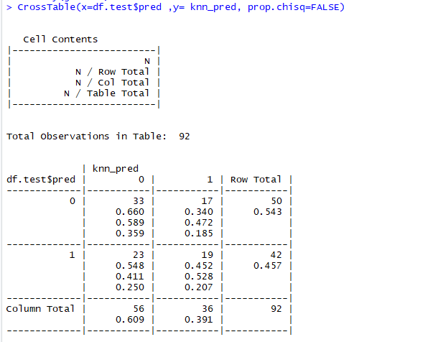

The accuracy rate = (33+19) /(33+17+23+19) =0.57 or 57% based on the confusion matrix.

In the above table we can see that 33% of patients don’t have heart disease (true negative) and that 19% have heart disease (true positive).

As seen in the table, 77/100 cases were accurately predicted total of 23% were incorrectly classified. This is a good start, but the model must improve if it is to be really used to diagnose patients. Mistakes in this domain are extremely consequential. We are going to try to improve the model by making the k value 5.

**If K=3**  **If k=5**

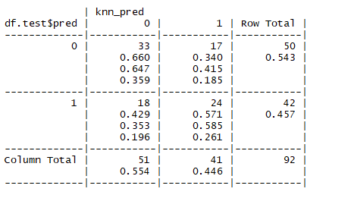 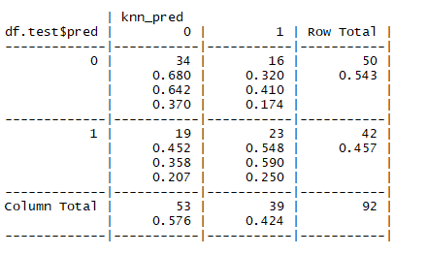The accuracy rate = (33+24) / (33+17+18+24) = 0.62(62%)The accuracy rate = (34+23) /(34+16+19+23)=0.62**(62%)**

**If k=15** **If k=22**

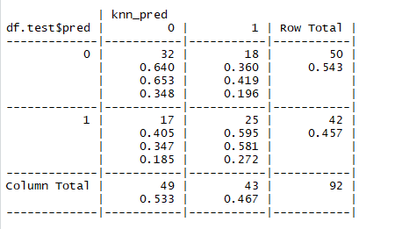 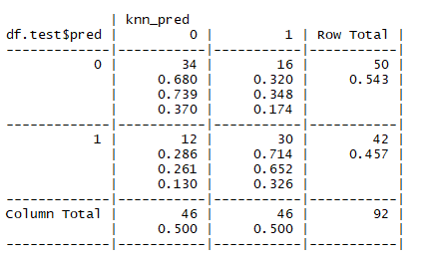

The accuracy rate = (32+25) / (32+18+17+25) = 0.62 (62%) The accuracy rate = (34+30) / (34+16+12+30) = 0.70 (70%)

|  |  |  |  |  |  |
| --- | --- | --- | --- | --- | --- |
| **K value** | **True positive** | **True Negative** | **False negative** | **False Positive** | **Percent classified incorrect** |
| 1 | 33 | 19 | 23 | 17 | 23 |
| 3 | 33 | 24 | 18 | 17 | 18 |
| 5 | 34 | 23 | 19 | 16 | 19 |
| 15 | 32 | 25 | 17 | 18 | 17 |
| **22** | **34** | **30** | **12** | **16** | **12** |

We can see that the most optimal result of the algorithm with k =22, the accuracy rate is 70% based on the measurement the performance of classification method. In order to calculate the result, we needed to follow the following formula:

**Accuracy = (True positive + true negative) / (true positive = true negative +false positive + false negative)**

We can state that for this problem we identified that accuracy rate of the prediction of the heart rate is 70%. It’s still not accurate enough to use to diagnose heart disease but might be good enough for the assignment! A better idea for this problem is to use a larger training set - more data would certainly help. Although, KNN might not be the optimal machine learning method for this problem.